- Watermelon

Problem Statement:
In this problem, we are given the weight of a watermelon in kilograms. We need to check whether it is possible to divide the watermelon into two parts such that both parts have even weights and both parts are greater than zero. If it is possible, we print YES. Otherwise, we print NO

Theory/Approach:
To solve this problem, I first observed that:
- An even number can be split into two even numbers
- But the smallest even number is 2, and 2 cannot be split into two positive even numbers
So, for the division to be possible:
- The weight must be even
- The weight must be greater than 2
If both conditions are true, the answer is YES. Otherwise, the answer is NO

Code:

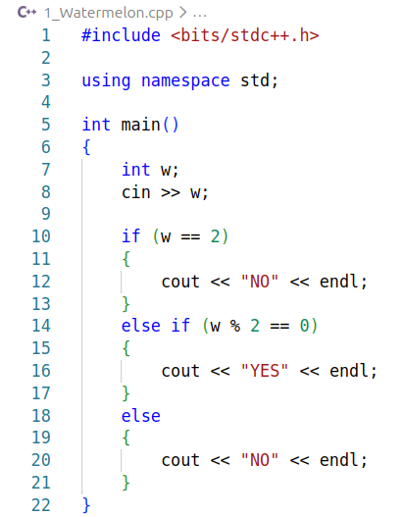

Output:
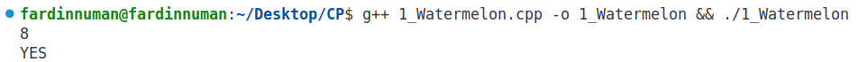

Verdict: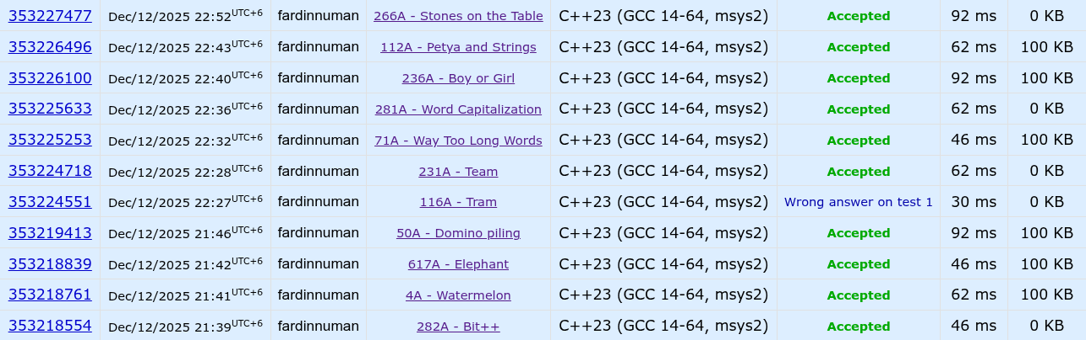

Discussion:
- Time Complexity: O(1), because no loop is used
- Space Complexity: O(1), no extra memory is needed
- Insights: This problem mainly tests logical thinking, not coding difficulty

- Bit++

Problem Statement:
We start with a variable x = 0. We are given several operations like ++X, X++, --X, X--. We have to calculate the final value of x

Theory/Approach:
- Read each operation as a string
- The middle character of the string decides the operation:
  - For '+' , we get increment
  - For '-' , we get decrement
This works because the problem guarantees that the operator is always at index 1

Code:

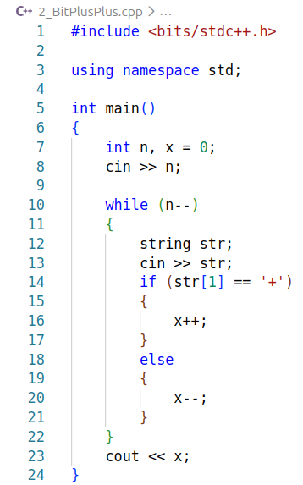

Output:
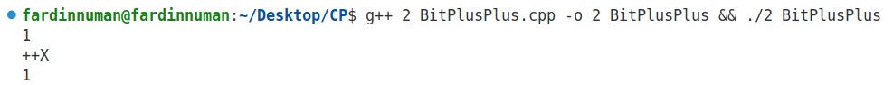
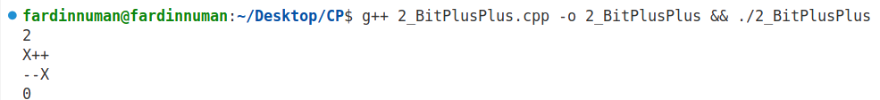

Verdict:

Discussion:
- Time Complexity: O(n)
- Space Complexity: O(1)
- Insights: Small observation can greatly simplify code

3. Elephant

Problem Statement:
An elephant wants to reach a point at distance n. It can move 1 to 5 steps at a time. We have to find the minimum number of moves required

Theory/Approach:
The elephant should always take the largest step possible (5). So, the minimum number of steps is: (n + 4) / 5. This formula ensures correct rounding up

Code:
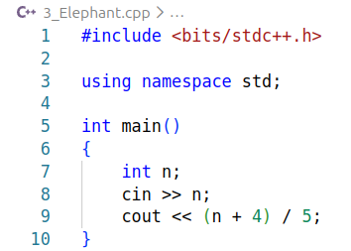

Output:
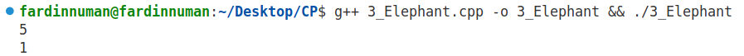
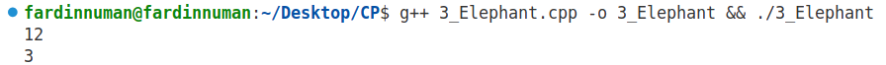

Verdict:

Discussion:
- Time Complexity: O(1)
- Space Complexity: O(1)
- Insights: Greedy approach works best here

4. Domino Piling

Problem Statement:
We are given the dimensions of a rectangular board with n rows and m columns. Each domino covers exactly two adjacent cells. Our task is to find the maximum number of dominoes that can be placed on the board without overlapping

Theory/Approach:
- The total number of cells in the board is n × m
- Since each domino covers 2 cells, the maximum number of dominoes is: (n × m) / 2
- We take integer division because partial dominoes cannot be placed
This approach works because domino placement depends only on the total number of cells

Code:
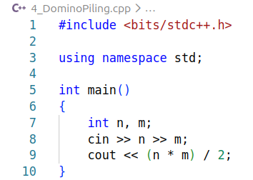

Output:

Verdict:

Discussion:
- Time Complexity: O(1), constant time
- Space Complexity: O(1), no extra memory used
- Insights: Sometimes problems can be solved using simple math instead of simulation

5. Team

Problem Statement:
A team has three members. For each problem, each member either knows the solution (1) or does not know (0). The team will solve the problem only if at least two members know the solution. We need to count how many problems the team can solve

Theory/Approach:
For each problem:
- Take three integers
- Add them
- If the sum is greater than or equal to 2, increase the answer count
This works because when the sum is 2 or 3, it means at least two people agreed to solve the problem

Code:
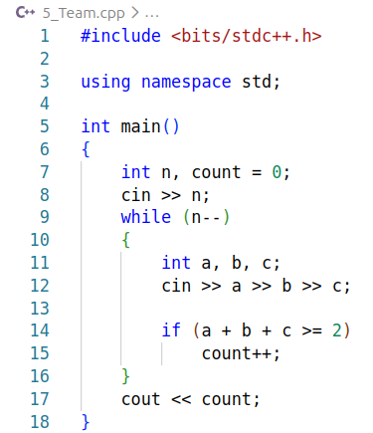

Output:
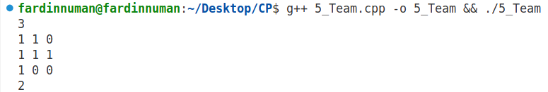
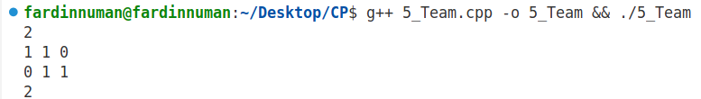

Verdict:

Discussion:
- Time Complexity: O(n)
- Space Complexity: O(1)
- Insights: Summing binary values simplifies logic
6. Way Too Long Words

Problem Statement:
We are given several words. If a word has more than 10 characters, we must shorten it by keeping the first and last character and replacing the middle characters with their count. If the word has 10 or fewer characters, we print it as it is

Theory/Approach:
For each word:
- Check the length of the string
- If length > 10:
  - Print first character
  - Print number of characters between first and last
  - Print last character
- Else, print the word normally
This works because the problem only cares about shortening long words, not modifying short ones

Code:

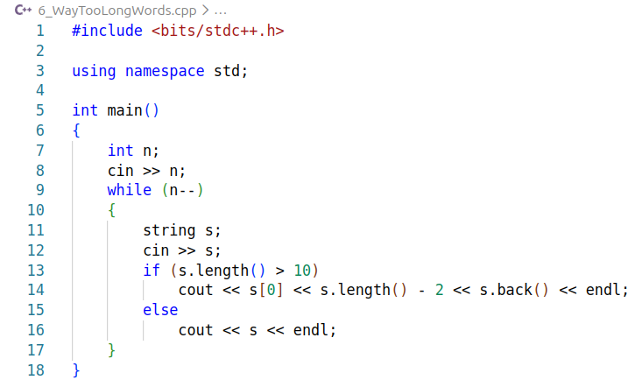

Output:
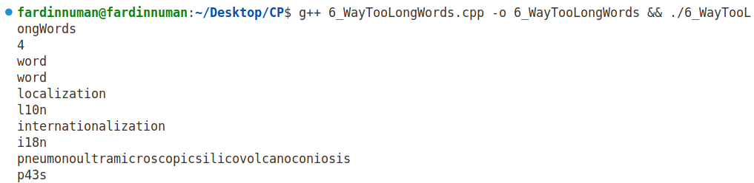

Verdict:

Discussion:
- Time Complexity: O(n), where n is the number of words
- Space Complexity: O(1) extra space
- Insights: String length checking is very useful in many problems

7. Word Capitalization

Problem Statement:
We are given a word, we need to convert only the first character to uppercase. All other characters must remain unchanged

Theory/Approach:
- Check the first character
- If it is lowercase, convert it to uppercase using ASCII values or toupper()

Code:

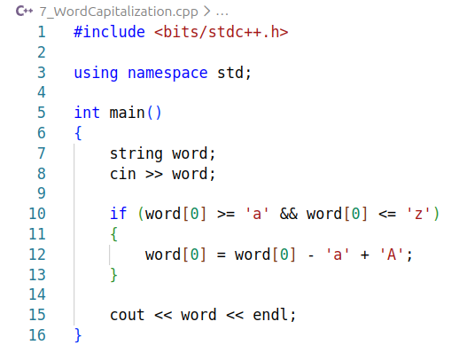

Output:
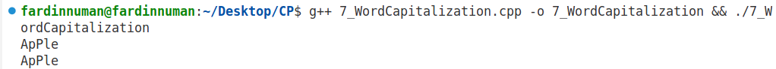
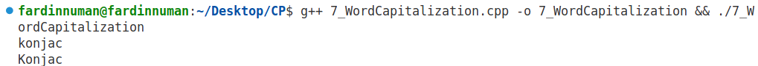

Verdict:

Discussion:
- Time Complexity: O(1)
- Space Complexity: O(1)
- Insights: ASCII manipulation is useful in character problems

8. Boy or Girl

Problem Statement:
In this problem, we are given a username as a string. We need to determine whether the user is a boy or a girl based on the number of distinct characters in the username.
- If the number of distinct characters is even, we will print "CHAT WITH HER!"
- If the number is odd, we will print "IGNORE HIM!"

Theory/Approach:
To solve this problem:
- I used a set to store all unique characters of the username
- A set automatically removes duplicate characters
- After inserting all characters, I checked the size of the set
- If the size is even, the answer is CHAT WITH HER!
- Otherwise, the answer is IGNORE HIM!

Code:

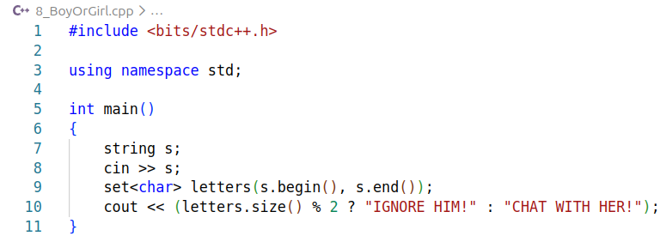

Output:
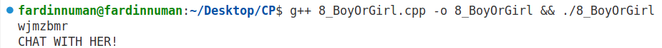
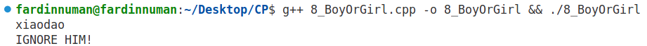
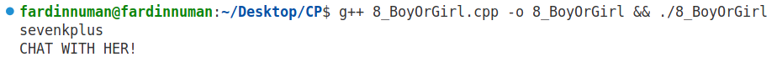

Verdict:

Discussion:
- Time Complexity: O(n), where n is the length of the username
- Space Complexity: O(n), because the set stores unique characters
- Insights: Sets are very useful when uniqueness matters

9. Petya and Strings

Problem Statement:
We are given two strings. Our task is to compare them lexicographically, but without considering lettercase
- Print -1 if the first string is smaller
- Print 1 if the first string is larger
- Print 0 if both strings are equal

Theory/Approach:
To compare the strings correctly:
- First, convert both strings to the same case (lowercase)
- Then compare the strings character by character
- Based on the comparison, print -1, 1 or 0
This works because converting both strings to lowercase removes case differences

Code:

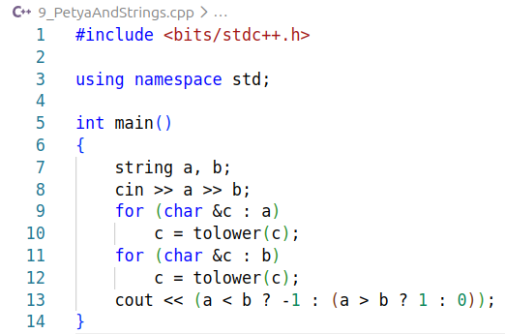

Output:
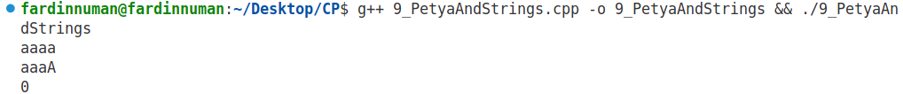
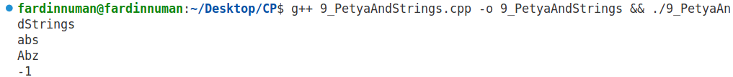
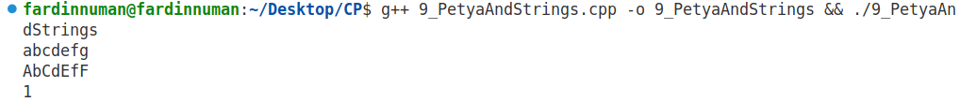

Verdict:

Discussion:
- Time Complexity: O(n), where n is the string length
- Space Complexity: O(n), due to storing lowercase versions
- Insights: Case-insensitive comparison is common in real applications

10. Stones on the Table

Problem Statement:
We are given a row of stones where each stone has a color. We must remove the minimum number of stones so that no two adjacent stones have the same color

Theory/Approach:
- Loop through the string from the second character
- If the current stone color is the same as the previous one, increment a counter
We don’t actually remove stones; we only count how many removals are needed.

Code:

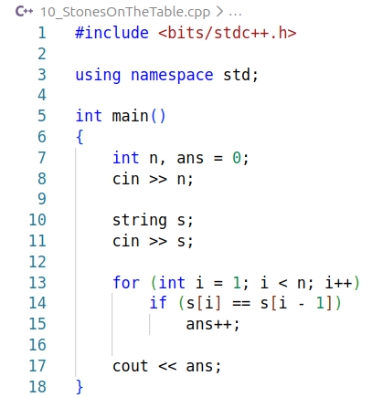

Output:
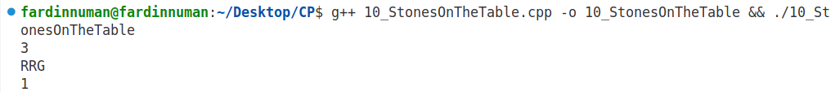
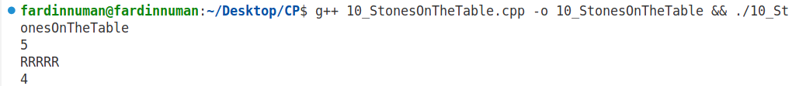
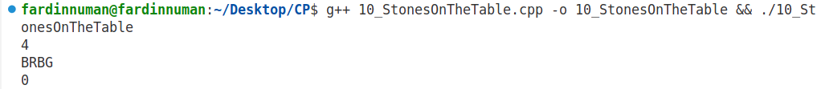

Verdict:

Discussion:
- Time Complexity: O(n)
- Space Complexity: O(1)
- Insights: Adjacent comparisons are common in string problems

